Chapter 9, Problem 69.

Find the equivalent admittance Y_{eq} of the circuit in Fig. 9.76.

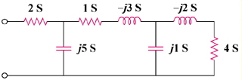

Figure 9.76
For Prob. 9.69.

